***Departement of Computer Science***

6/17/2020

DBMS LAB

Cource Code : CS254

II B.Tech-IV Semester

Academic Year 2019-2020

Project Based On

**RAILWAY RESERVATION SYSTEM**

Submitted By

Section: 1

1.Awanit Ranjan (181CO161)

2.Vivek Kumar (181CO159)

**INDEX**

1. **INTRODUCTION**
2. **PROJECT DECRIPTION**
3. **SYSTEM ANALYSIS**

**i)EXISTING SYSTEM**

**ii)PROPOSED MODEL**

1. **LIST OF ENTITIES AND ATTRIBUTES**
2. **ER DIAGRAME (CONCEPTUAL MODEL)**
3. **SCHEMA**
4. **NORMALIZATION**
5. **IMPLEMENTATION (CODE)**
6. **BASICS FOR DATABASE POPULATION**

**10. SCREEN-SHOTS FOR THE OUTPUT**

**11. YOUTUBE/GITHUB/G-DRIVE LINKS FOR PROJECT**

**12. CONCLUSION AND REFERENCES**

C

**INTRODUCTION**

Database is an organized collection of data. The data is typically organized to model aspects of reality in a way that supports processes requiring information. A DBMS makes it possible for end users to create, read, update and delete data in a database. The DBMS essentially serves as an interface between the database and end users or application programs, ensuring that data is consistently organized and remains easily accessible. The DBMS manages three important things: the data, the database engine that allows data to be accessed, locked and modified and the database schema, which defines the database’s logical structure. These three foundational elements help provide concurrency, security, data integrity and uniform administration procedures. The DBMS can offer both logical and physical data independence. That means it can protect users and applications from needing to know where data is stored or having to be concerned about changes to the physical structure of data.

The main purpose of maintaining database for Railway Reservation System is to reduce the manual errors involved in the booking and cancelling of tickets and make it convenient for the customers and providers to maintain the data about their customers and also about the seats available at them.Due to automation many loopholes that exist in the manual maintenance of the records can be removed. The speed of obtaining and processing the data will be fast. For future expansion the proposed system can be web enabled so that clients can make various enquiries about trains between stations. Due to this, sometimes a lot of problems occur and they are facing many disputes with customers. To solve the above problem, we design a data base which includes customer details, availability of seat, no of trains and their details.

PROJECT DESCRIPTION

This project is about creating the database about Railway Reservation System.

The railway reservation system facilitates the passengers to enquire about the trains available on the basis of source and destination, booking and cancellation of tickets, enquire about the status of the booked ticket, etc. The aim of case study is to design and develop a database maintaining the records of different trains, train status, and passengers. The record of train includes its number, name, source, destination, and days on which it is available, whereas record of train status includes dates for which tickets can be booked, total number of seats available, and number of seats already booked.

Passengers can book their tickets for the train in which seats are available. For this, passenger has to provide the desired train number and the date for which ticket is to be booked. Before booking a ticket for a passenger, the validity of train number and booking date is checked. Once the train number and booking date are validated, it is checked whether the seat is available. If yes, the ticket is booked with confirm status and corresponding ticket ID is generated which is stored along with other details of the passenger. The ticket once booked can be cancelled at any time. For this, the passenger has to provide the ticket ID (the unique key). The ticket ID is searched and the corresponding record is deleted. With this, the first ticket with waiting status also gets confirmed.

List of Assumption Since the reservation system is very large in reality, it is not feasible to develop the case study to that extent and prepare documentation at that level. Therefore, a small sample case study has been created to demonstrate

the working of the reservation system. To implement this sample case study, some assumptions have been made, which are as follows:

1. The number of Stations has been restricted to 5.

2. The booking is open only for next four month from the current date.

3. Only four categories of tickets can be booked, namely, SLEEPER, 1AC , 2AC & 3AC.

4. The total number of tickets that can be booked in each category is 10.

5. The total number of tickets that can be given the status of waiting is 0.

6. The in‐ between stoppage stations and their bookings are not considered.

List of trains has to be maintained. Detailed Passenger information is to be maintained In the booking procedure, the train number, train date, and category are read from the passenger. On the basis of the values provided by the passenger, corresponding record is retrieved from the Train_Status. If the desired category is AC, then total number of AC seats and number of booked AC seats are compared in order to find whether ticket can be booked or not. Similarly, it can be checked for the general category. If ticket can be booked, then passenger details are read and stored in the Passenger table. In the cancellation procedure, ticket ID is read from the passenger and corresponding record is searched in the Passenger. If the record exists, it is deleted. After deleting the record (if it is confirmed), first record with waiting status for the same train and same category are searched from the Passenger table and its status is changed to confirm.

SYSTEM ANALYSIS

System analysis is the process of gathering and interpreting facts, diagnosing problems and using the information to recommend improvements on the system. System analysis is a problem solving activity that requires intensive communication between the system users and system developers.

System analysis or study is an important phase of any system development process. The system is viewed as a whole, the inputs are identified and the system is subjected to close study to identify the problem areas. The solutions are given as a proposal. The proposal is reviewed on user request and suitable changes are made. This loop ends as soon as the user is satisfied with the proposal.

**EXISTING SYSTEM**

1. Information cannot be collected, processed and communicated more quickly and efficiently.
2. Current working systems doesn’t ensure that right information reaches the right person at the right time.

**PROPOSED MODEL**

1. Increased efficiency and reliability
2. Easier Access
3. Easy to Use
4. Effective utilization of available resource
5. User Friendly
6. Accuracy – The information will be correct, accurate and unambiguous.
7. Redundancy – The project has been designed in such a way so that it overcomes problem like data redundancy.
8. System Security – The system security has been kept into consideration will the database of the system cannot be accessed by any user either admin or a customer without being authenticated by correct username and password.

**LIST OF ENTITIES & ATTRIBUTES**

1. **USER**

Username, password, User_id

1. **TRAIN**

Train_id, No_of_seats , Source, Destination, Journey_distance, Seat_status

1. **PASSENGER**

Pass_id , Name, Age, Sex, Email, Country, Phone

1. **TICKET**

Ticket_id, PNR, Train_id, Date, Class, Price,User_id

1. **BOOK**

Book_id, Ticket_id

1. **CANCEL**

Cancel_id, Ticket_id

1. **TRAIN_DETAILS**

Train_no, Train_name, Start_time, Travel_time, Fare

**ER DIAGRAM (CONCEPTUAL MODEL)**

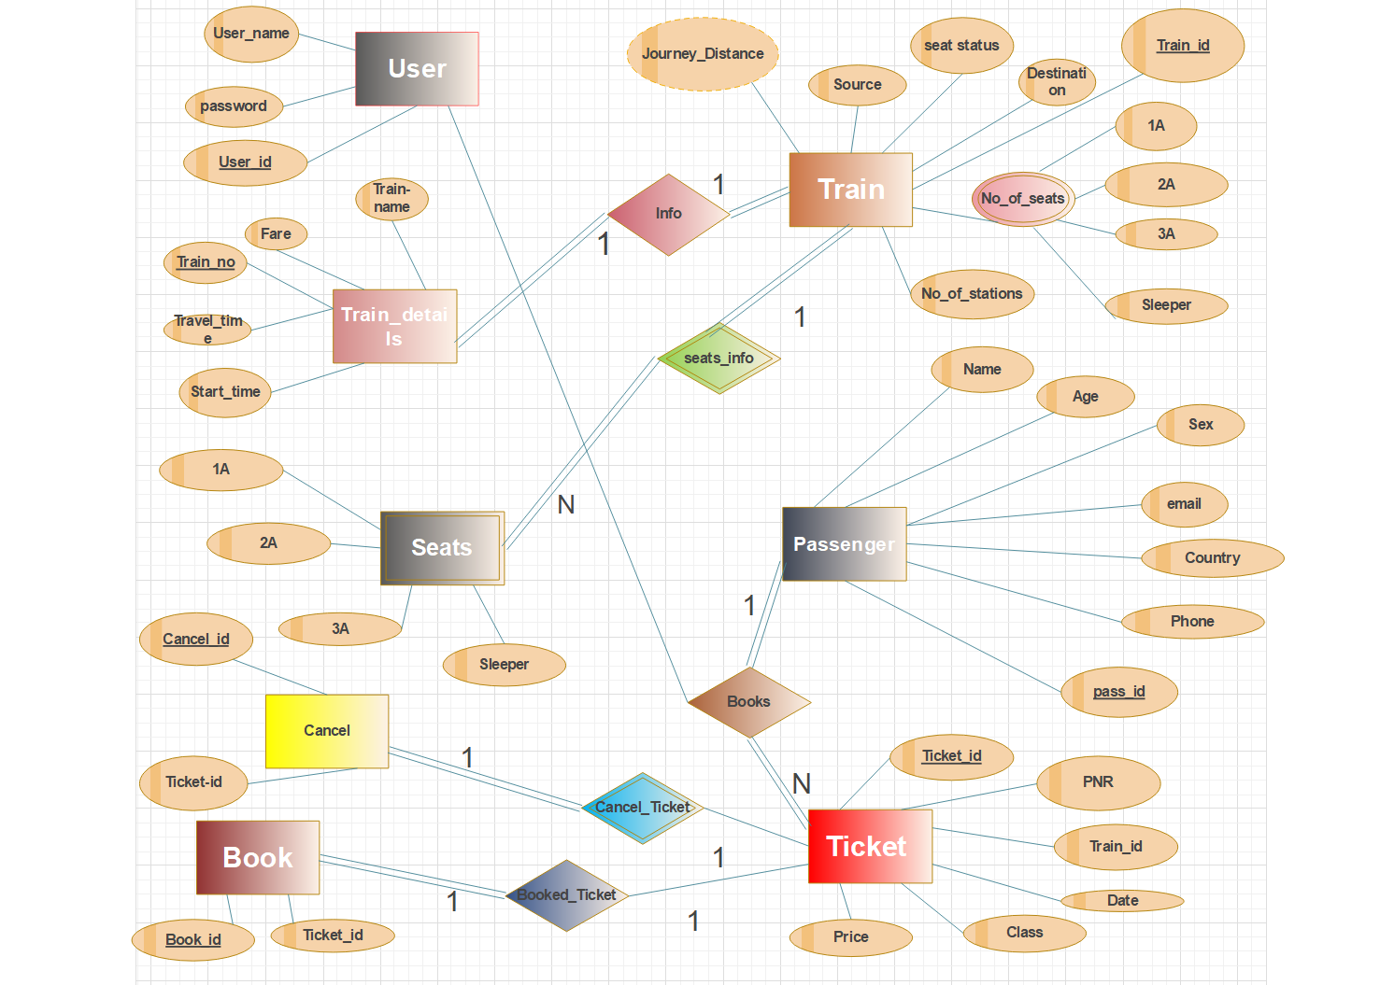

*This**ER diagrame is drawn on Edraw Max*

**SCHEMA**

**USER**

|  |  |  |
| --- | --- | --- |
| **User_id** | Username | Password |

**Train**

|  |  |  |  |  |  |  |
| --- | --- | --- | --- | --- | --- | --- |
| **Train_id** | Source | Destination | Seat_staus | Jorney_Distance | Seat_id | No_of_stations |

**No_of_seats_left**

|  |  |  |  |  |
| --- | --- | --- | --- | --- |
| Train_id | 1A | 2A | 3A | Sleeper |

**Train_details**

|  |  |  |  |  |  |
| --- | --- | --- | --- | --- | --- |
| **Train_Number** | Fare | Train_name | Travel_time | Train_id | Start_time |

**Seats**

|  |  |  |  |  |
| --- | --- | --- | --- | --- |
| **Seats_id** | 1A | 2A | 3A | Sleeper |

**Passengers**

|  |  |  |  |  |  |  |
| --- | --- | --- | --- | --- | --- | --- |
| **Pass_id** | Pass_name | Sex | Email | Phone_no | Country | Age |

**Book**

|  |  |
| --- | --- |
| Book_id | Ticket_id |

**Cancel**

|  |  |
| --- | --- |
| Cancel_id | Ticket_id |

**Ticket**

|  |  |  |  |  |  |  |
| --- | --- | --- | --- | --- | --- | --- |
| **Ticket_id** | Train_id | Pass_id | PNR | Price | Class | Date |

**Train_info**

|  |  |
| --- | --- |
| Train_number | Train_id |

**Seats_info**

|  |  |
| --- | --- |
| Train_id | Seats_id |

**NORMALIZATION**

User

|  |  |  |
| --- | --- | --- |
| User_Id | Username | Password |

Train_details

|  |  |  |  |  |  |
| --- | --- | --- | --- | --- | --- |
| Train_id | Source | Destination | Seat_status | Journey_Distance | No_of_stations |

Train

|  |  |  |  |  |  |
| --- | --- | --- | --- | --- | --- |
| Train_no | Fare | Train_name | Travel_Time | Train_id | Start_time |

Seats

|  |  |  |  |  |
| --- | --- | --- | --- | --- |
| Serts_id | 1A | 2A | 3A | Sleeper |

Complete_Train_Info

|  |  |  |
| --- | --- | --- |
| Train_id | Train_no | Seats_id |

Passenger

|  |  |  |  |  |  |  |
| --- | --- | --- | --- | --- | --- | --- |
| Pass_id | Pass_name | Sex | Email | Country | Phone_no | Age |

Ticket

|  |  |  |  |  |  |  |
| --- | --- | --- | --- | --- | --- | --- |
| Ticket_id | Pass_id | Train_id | PNR | Price | Class | Date |

Book

|  |  |
| --- | --- |
| Book_id | Ticket_id |

Cancel

|  |  |
| --- | --- |
| Cancel_id | Ticket_id |

Passenger_Ticket_book_Cancel

|  |  |  |  |
| --- | --- | --- | --- |
| Pass_id | Ticket_id | Book_id | Cancel_id |

**IMPLEMENTATION (Code)**

**Models**

**Train**

var TrainDataschema = new mongoose.Schema({ source:String , destination: String ,

train_details:[{ number:String, name:String, fare:Number, travel_time:String,

start_time: String, }],

no_of_seats:{one_A:Number,two_A:Number,three_A:Number,sleeper:Number},

seats_status:[{ type: mongoose.Schema.Types.ObjectId, ref: "Seats" }],

no_of_station:Number,

distance: String });

TrainDataschema.plugin(passportLocalMongoose);

module.exports=mongoose.model("Train",TrainDataschema);

**User**

var UserSchema=new mongoose.Schema({ username:String, password:String });

UserSchema.plugin(passportLocalMongoose);

module.exports=mongoose.model("User",UserSchema);

**Seats**

var Seatsschema = new mongoose.Schema({ one_A:Number, two_A:Number, three_A:Number, sleeper:Number });

Seatsschema.plugin(passportLocalMongoose);

module.exports=mongoose.model("Seats",Seatsschema);

**Cancel**

var Cancelschemaqwe = new mongoose.Schema({ ticket :[{

type: mongoose.Schema.Types.ObjectId, ref: "Ticket" }]});

Cancelschemaqwe.plugin(passportLocalMongoose);

module.exports=mongoose.model("Cancelcel",Cancelschemaqwe);

**Book**

var Bo = new mongoose.Schema({ tick :[{type: mongoose.Schema.Types.ObjectId,

ref: "Tick" }], f:{type:Number,default:512} });

Bo.plugin(passportLocalMongoose);

module.exports=mongoose.model("Bo",Bo);

**Ticket**

var Tick = new mongoose.Schema({ status:String, train_id:String, date:String, classs:String,

price:Number,PNR:String, pass:{ type: mongoose.Schema.Types.ObjectId, ref: "Pass"}});

Tick.plugin(passportLocalMongoose);

module.exports=mongoose.model("Tick",Tick);

**Passenger**

var Passenger = new mongoose.Schema({ name:String, age:Number, sex:{ type:String , default:"Male"}, email:String, phone: Number, country:{ type:String , default:"INDIAN"} });

Passenger.plugin(passportLocalMongoose);

module.exports=mongoose.model("Pass",Passenger);

models requirements

*Importing models in our server file app.js*

var User = require("./models/user") ,

Seats = require("./models/seats") ,

Train = require("./models/train") ,

Tick = require("./models/tick") ,

Pass = require("./models/pass") ,

Cancelcel = require("./models/cancel512") ,

Bo = require("./models/bo") ;

**Basics For Database Population**

**for Database Population**

**Seats:**

db.seats.insert({one_A : 111, two_A : 111, three_A : 111, sleeper : 111 });

db.seats.insert(one_A : 111, two_A : 111, three_A : 111, sleeper : 111 });

db.seats.insert({one_A : 111, two_A : 111, three_A : 111, sleeper : 111 });

db.seats.insert({one_A : 111, two_A :111, three_A : 111, sleeper :111 });

**Train:**

db.trains.insert({ source : "MANGALORE", destination : "KOLKATA", train_details : [ { number : "7225", name : "KAVGDI EXPRESS", fare : 1143, travel_time : "29H:30min:21sec", start_time : "19:10" } ], no_of_seats : { one_A :11, two_A : 11 ,three_A :11, sleeper :11 }, no_of_station : 59, distance : "1979 Km", seats_status : [ ObjectId("5e8d93372b984d6314d763e5 ")]});

db.trains.insert({ source :"PATNA" , destination :"MANGALORE" , train_details : [ { number : "1225", name : "RAJDGI EXPRESS", fare : 1713, travel_time : "31H:05min:10sec", start_time : "19:10" } ], no_of_seats : { one_A : 111 , two_A : 111 , "three_A" : 111, sleeper : 111 }, no_of_station : 91, distance : "989 Km",seats_status : [ ObjectId(" 5e8d93372b984d6314d76332")]});

db.trains.insert({ source : "PATNA", destination : "DELHI", train_details : [ { number : "4258", name : "GOMTI EXPRESS", fare : 2084, travel_time : "19H:30min:21sec", start_time : "10:00" } ], no_of_seats : { one_A : 54, two_A:68 , three_A : 15, sleeper : 71}, no_of_station : 31, distance : "3098 Km", seats_status : [ ObjectId("5e8d93372b984d6314d763d5")]});

db.trains.insert({ source : "MUMBAI", destination : "BANGALORE", train_details : [ { number : "5121", name : "GARIBH RATH EXPRESS", fare : 1111, travel_time : "12H:32min:01sec", start_time : "1:00" } ], no_of_seats : { one_A :44, two_A :68 , three_A :15, sleeper : 73 }, no_of_station : 10, distance : "1118 Km", seats_status : [ ObjectId("5e8d93372b984d6314d763d6")]});

db.trains.insert({ source :"CHENNAI" , destination :"PATNA" , train_details : [ { number : "1001", name : "RAJDHANI EXPRESS", fare : 1113, travel_time : "35H:05min:10sec", start_time : "15:00" } ], no_of_seats : { one_A : 24, two_A : 68, "three_A" : 15, sleeper : 73 }, no_of_station : 12, distance : "988 Km",seats_status : [ ObjectId("5e8d93372b984d6314d763d7")]});

db.trains.insert({ source : "PATNA", destination : "KOLKATA", train_details : [ { number : "0285", name : "SABARMATI EXPRESS", fare : 1143, travel_time : "20H:30min:21sec", start_time : "12:00" } ], no_of_seats : { one_A :94, two_A : 24 ,three_A :24, sleeper :51 }, no_of_station : 59, distance : "1975 Km", seats_status : [ ObjectId("5e8d93372b984d6314d763d8")]});

**Screen-Shots for Output**

**Signup Form**

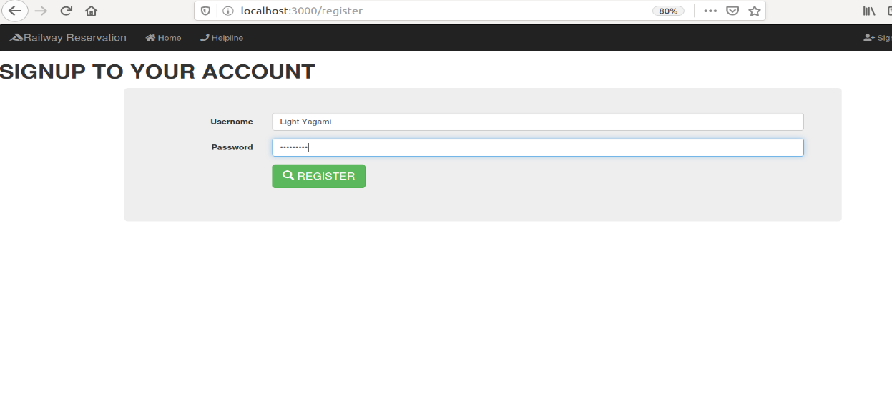

**Login Form**

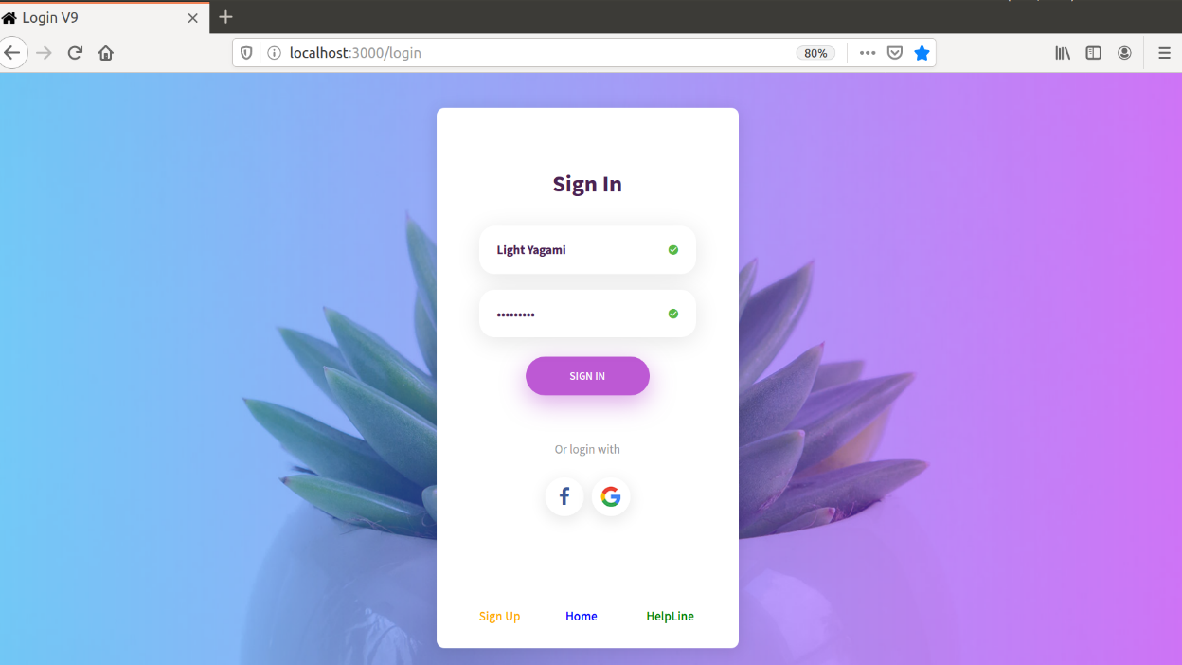

**Train Search**

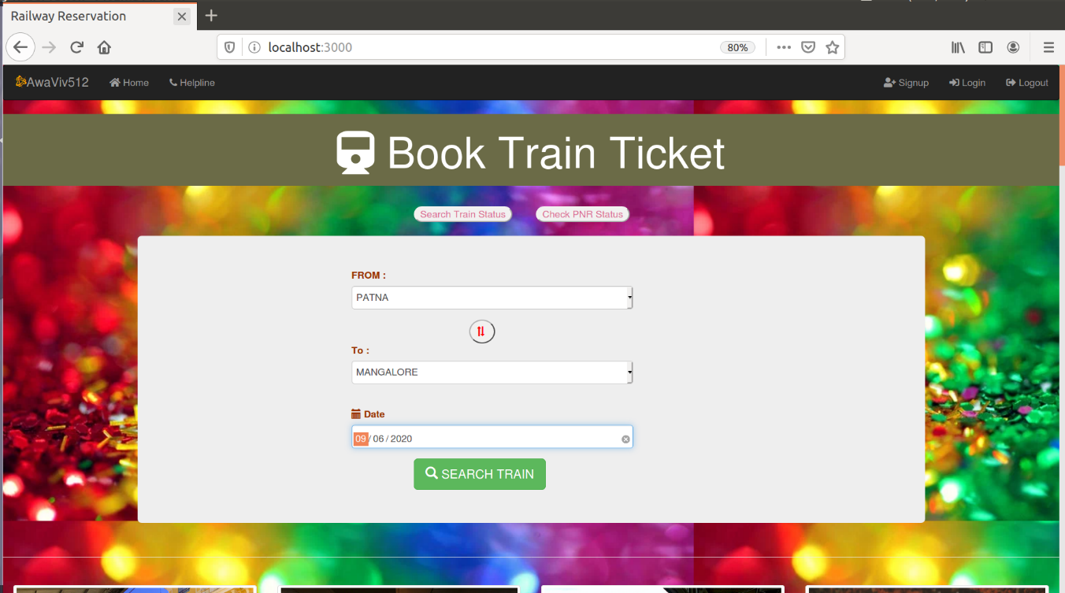

**List of All Available Train For that Route**

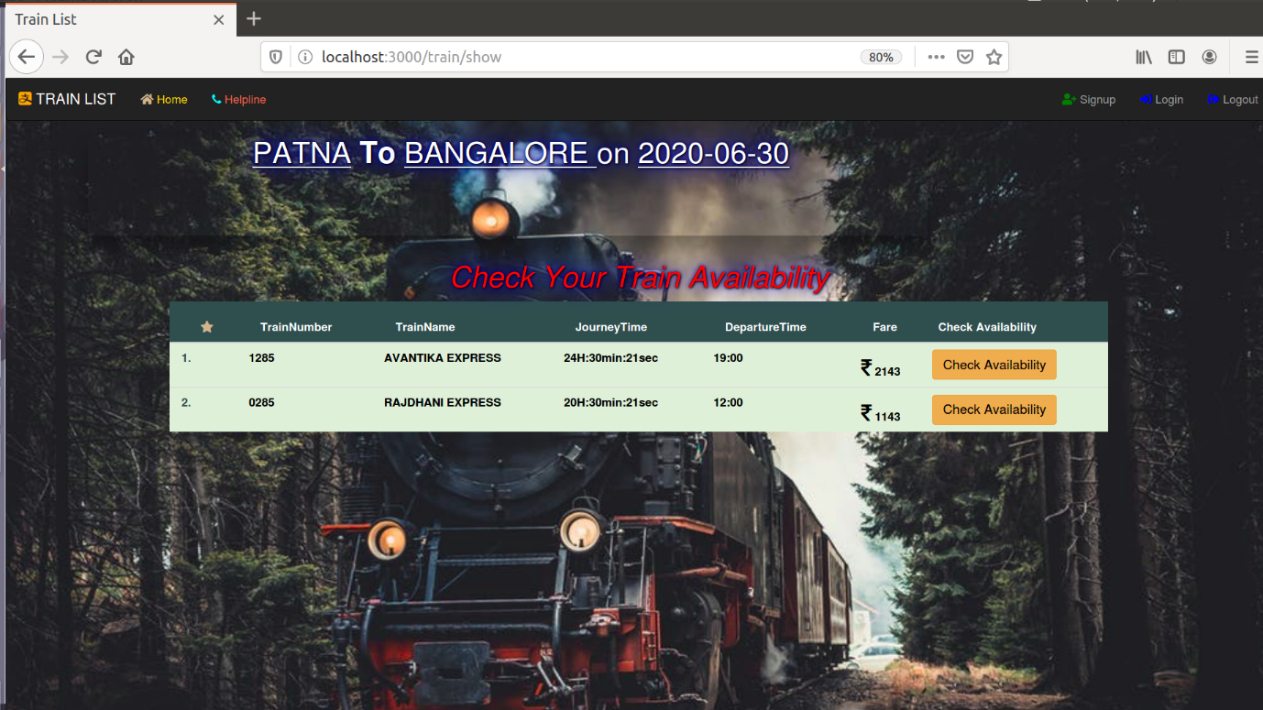

**Particular Train Classes and its Fare**

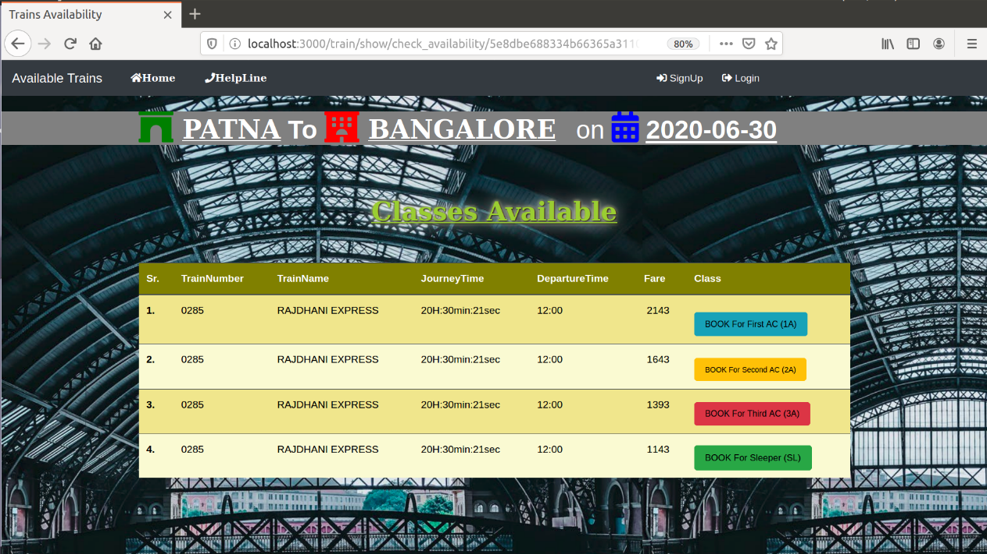

**Finding Ticket by PNR**

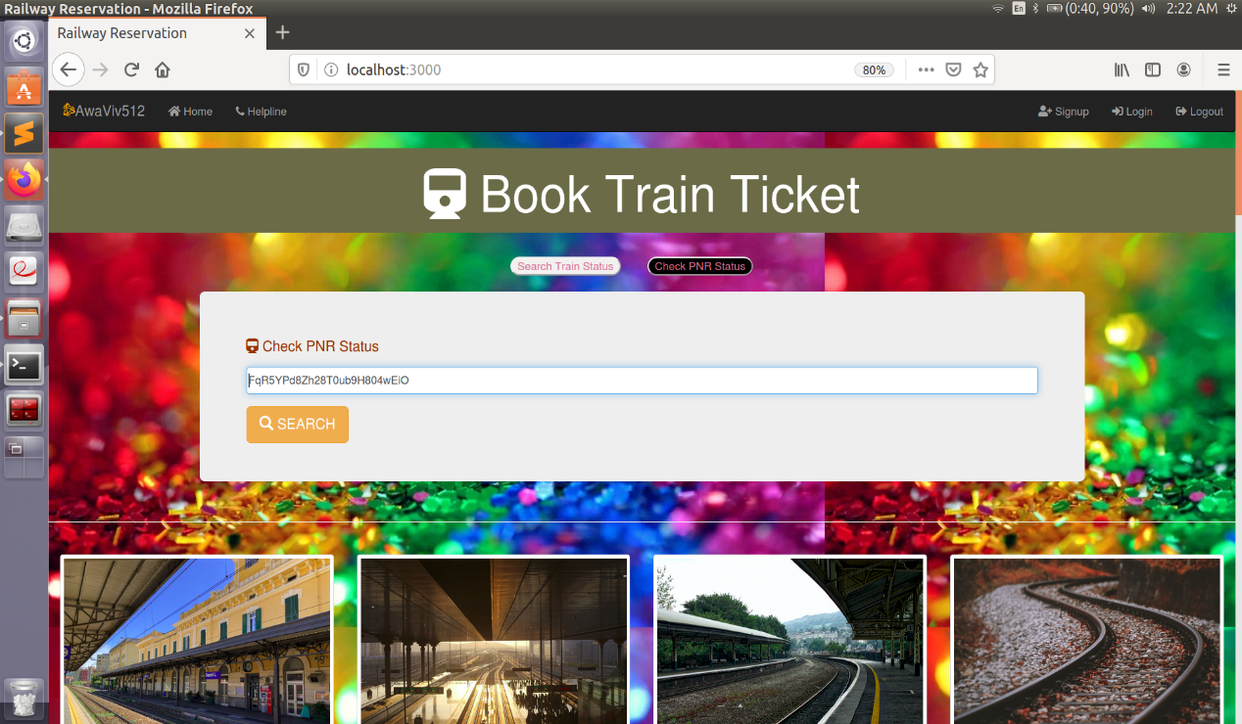

**Ticket Booking Form**

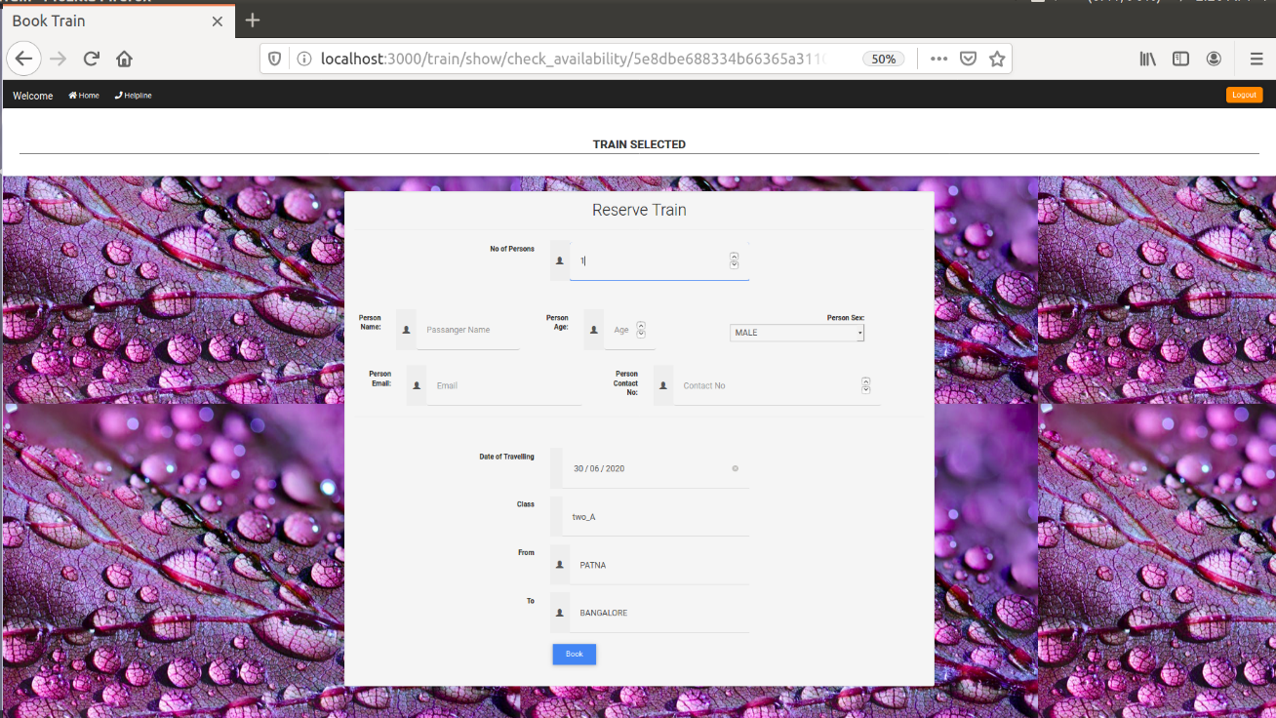

**Booked E-Ticket**

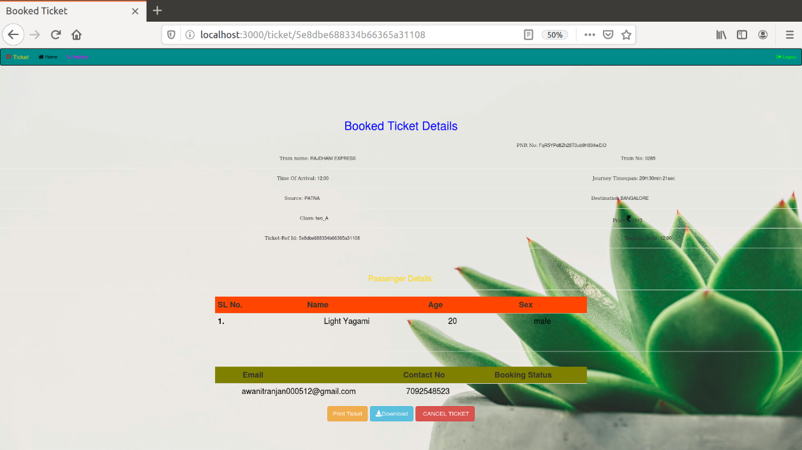

**Cancel-Ticket**

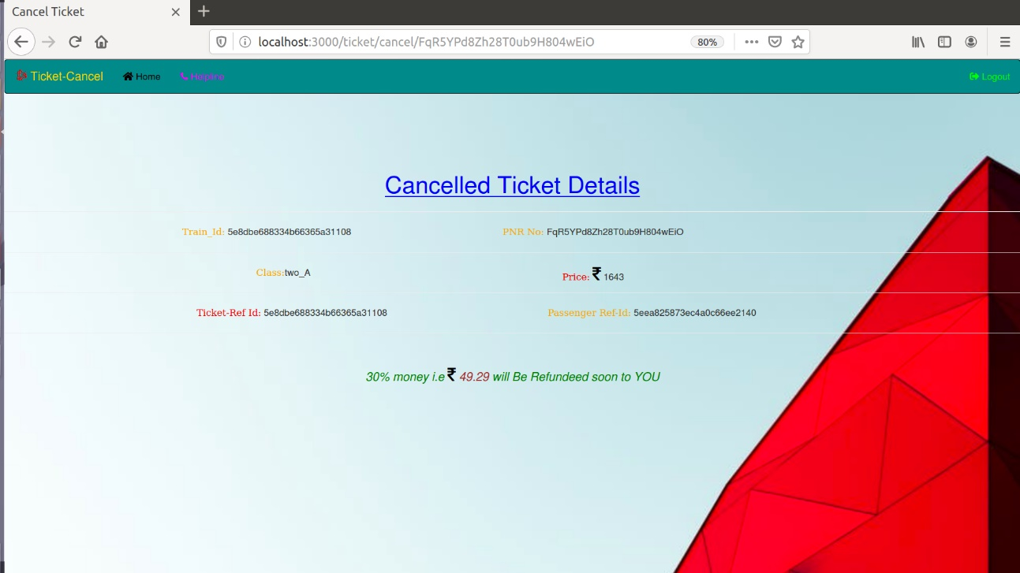

**Databases Screen-Shots:**

**Query For Showing All the Trains**

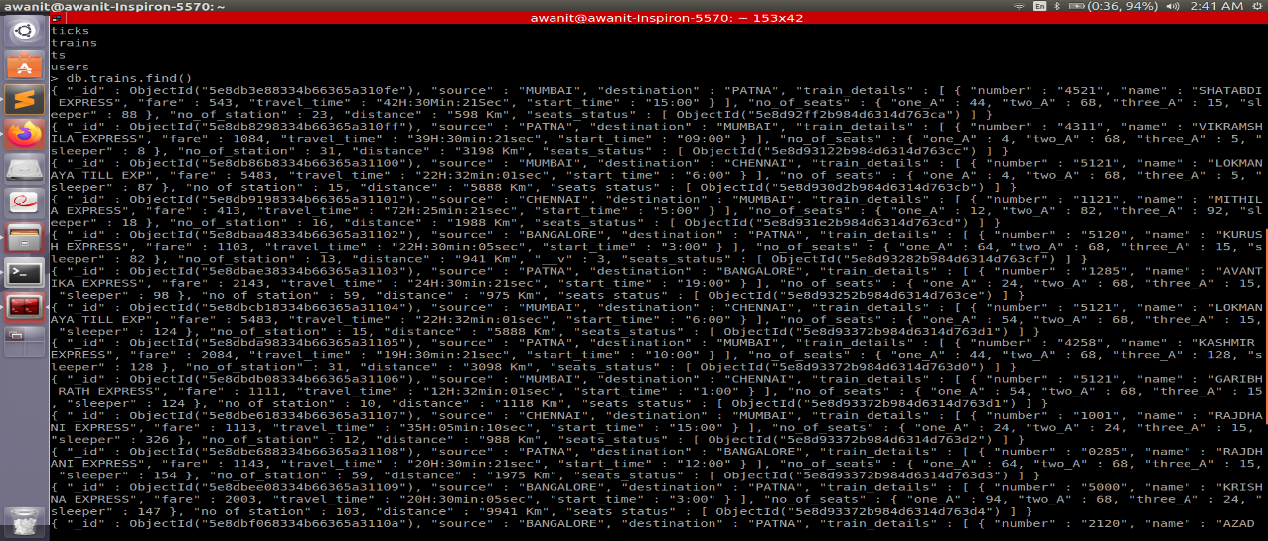

**Query for Showing All The Ticket**

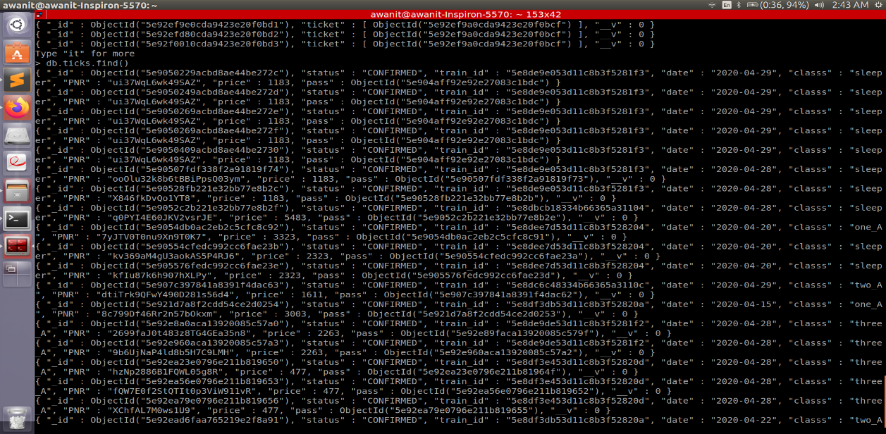

**Query for Showing All The Passengers**

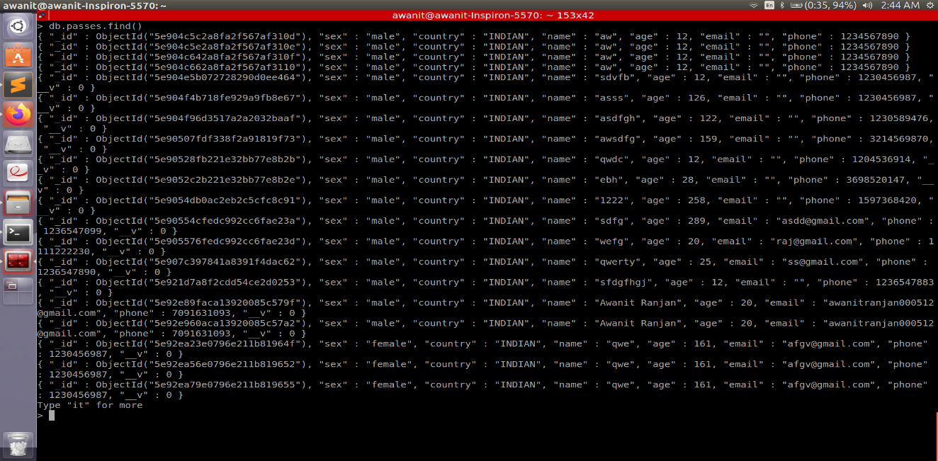

**Query For Showing All Canceled and Booked Ticket**

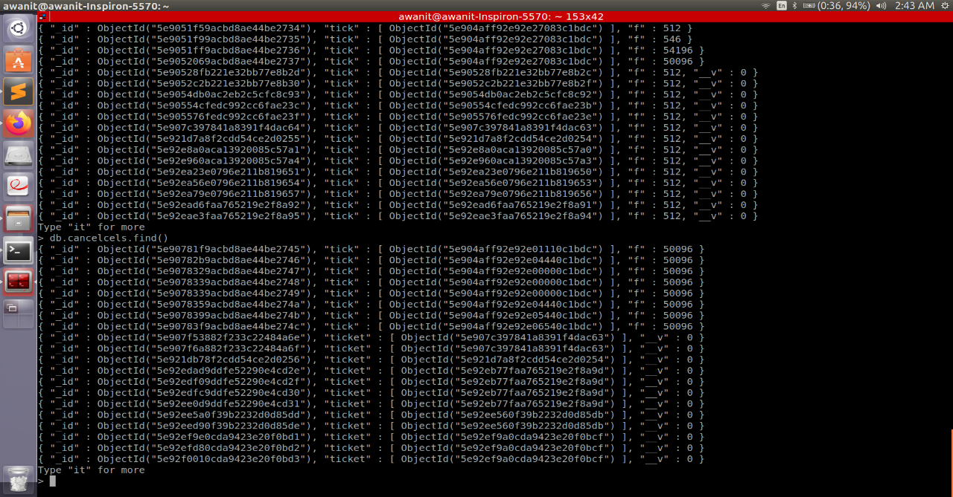

**All the Collections**

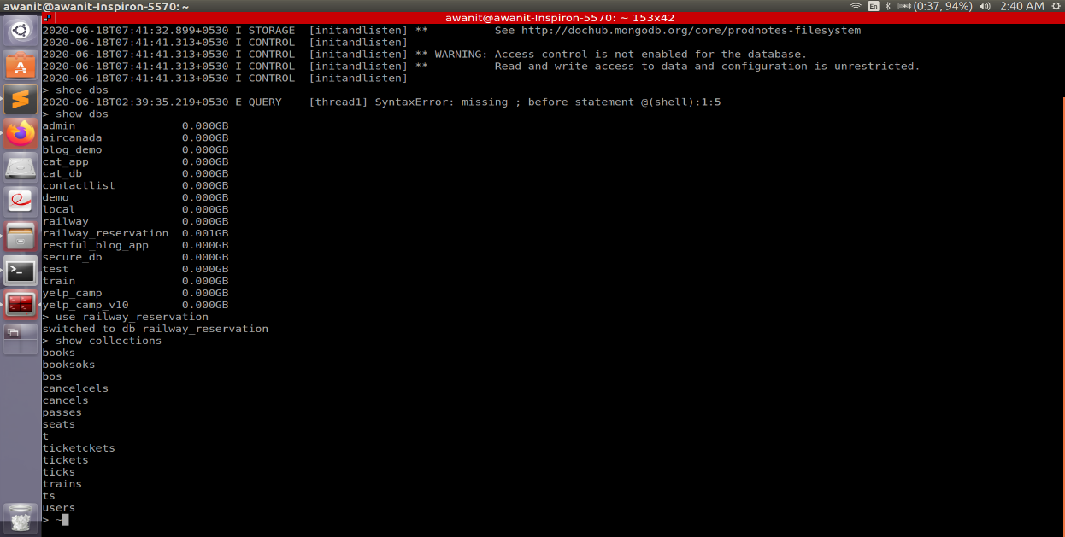

**: Youtube video of the project :**

[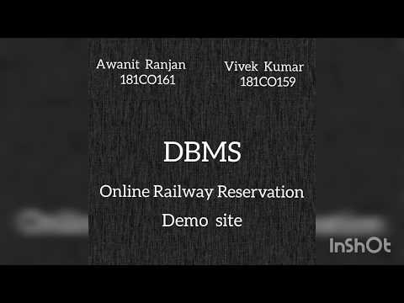](https://www.youtube.com/embed/yWLxftflbmU?feature=oembed)

Code can be found Here :

Github code link:

<https://github.com/Awanit512/DBMS-Online-Railway-Reservation-System.git>

Google Drive code link:

<https://drive.google.com/drive/folders/1hoFGgeIU_OMZyC1pMqtmQBtPYP3TO1Qx?usp=sharing>

Youtube Project video link:

<https://youtu.be/yWLxftflbmU>

**CONCLUSION**

In our project Railway reservation system we have stored all the information about the Trains scheduled and the users booking tickets and even status of trains, seats etc. This data base is helpful for the applications which facilitate passengers to book the train tickets and check the details of trains and their status from their place itself it avoids inconvenience of going to railway station for each and every query they get. We had considered the most important requirement only, many more features and details can be added to our project in order to obtain even more user friendly applications. These applications are already in progress and in future they can be upgraded and may become part of amazing technology.

***References:***

Henry F Korth , *Abraham* Silberschatz ‘Database system Concepts’ T.M.H 2nd Edition.

[*www.yatra.com*](http://www.yatra.com)

[*www.w3school.com*](http://www.w3school.com)

[*https://mongoosejs.com/docs/*](https://mongoosejs.com/docs/)